Loop through arguments and copy every property of every object passed to the function. And the result will be a new object that has the properties of all the source objects.

[复制代码](javascript:void(0);)

function mix() {

var arg, prop, child = {};

for (arg = 0; arg < arguments.length; arg += 1) {

for (prop in arguments[arg]) {

if (arguments[arg].hasOwnProperty(prop)) {

child[prop] = arguments[arg][prop];

}

}

}

return child;

}

var cake = mix({

eggs: 2,

large: true

}, {

butter: 1,

salted: true

}, {

flour: "3 cups"

}, {

sugar: "sure!"

});

console.dir(cake);

[复制代码](javascript:void(0);)

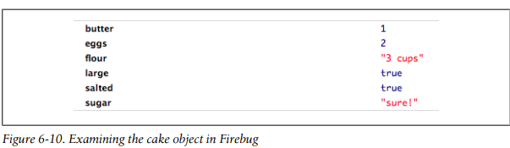

**References*:***

*JavaScript Patterns -*by Stoyan Stefanov (O`Reilly)